### Working Views

Working views are intended to support the modeling and design documentation process. The Revit Coordinator should delete working views that are not regularly used to maintain model performance and reduce overall file size.

Best Practice:

* Each user will identify non-sheet, working views with their initials.

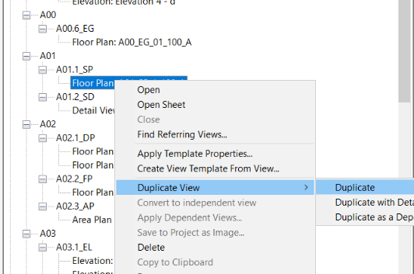

Figure 4.1‑3 Create Working Views by Duplicating

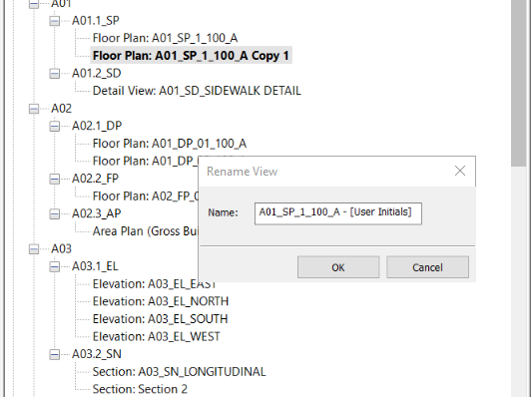

Figure 4.1‑4 Include User’s initials in Working View’s Name